AI Movement (by Europa & Pilien)

//Finding Cites/forts code
//Choosing Closest City/fort code
//Finding path Code
//Moving Code
//comments and indicate values that are strictly for this example

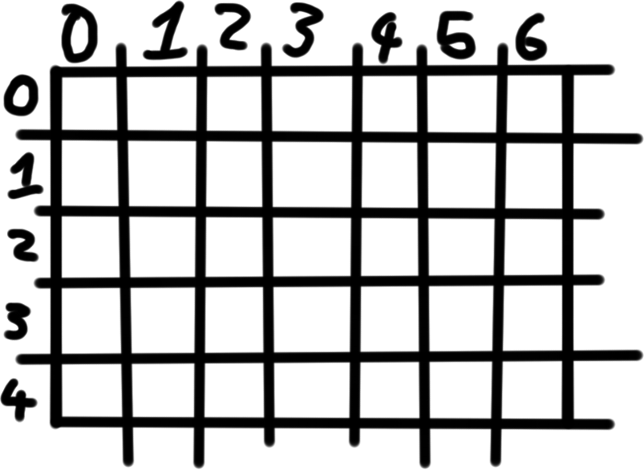

The map as the AI knows it, so far.

List xList;
List yList;
int col = 0; the column that the AI side starts
int row = 0;

while (col <= 6 the last column){
while (row <= 4 bottom row){
if (Tile[col][row] has a city that is able to conquer)
xList.add(col);
yList.add(row);
row++;
}
row = 0;
col++;
}

Found those unoccupied cities
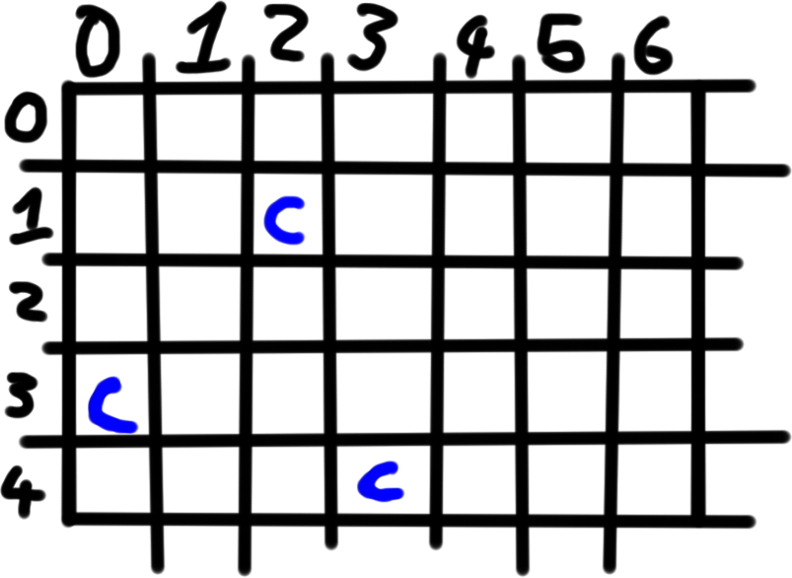

col = 0;
row = 0;
int Ecol = 0;
int Erow = 0;
while (col <= 6){
while (row <= 4 bottom row){
if (Tile[col][row] is where army is)
Ecol = col;
Erow = row;
row++;
}
row = 0;
col++;
}

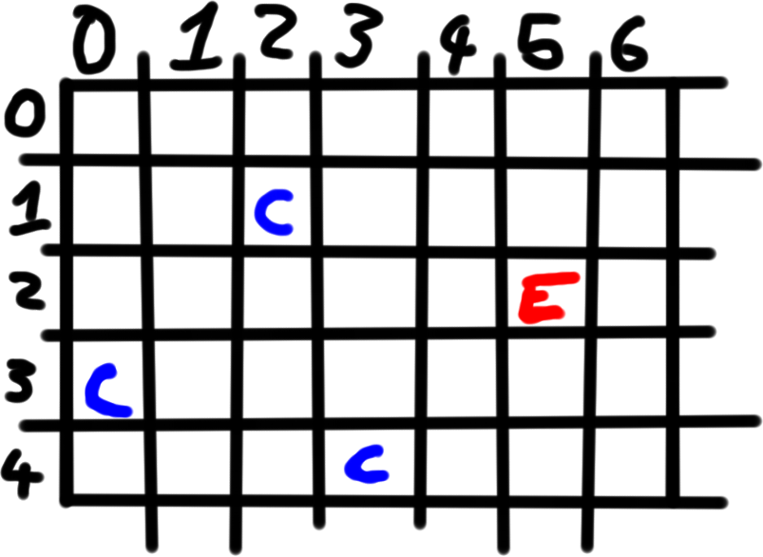

AI found itself

int TempCol[] = new int[2];
int TempRow[] = new int[2];

TempCol[0] = 10000;
TempRow[0] = 10000;

Int i = 0;

while (i <= xList.size){
int x = xList(i);
int y = yList(i);
int xx = x – Ecol;
int yy = y – Erow;

if (xx < 0){
xx = xx * -1;
}
if (yy < 0){
yy = yy * -1;
}
if (xx <= TempCol[0] && yy <= TempRow[0]){
TempCol[0] = xx;
TempRow[0] = yy;
TempCol[1] = x;
TempRow[1] = y;
}
}
int xC = TempCol[1];
int yC = TempRow[1]

Found you

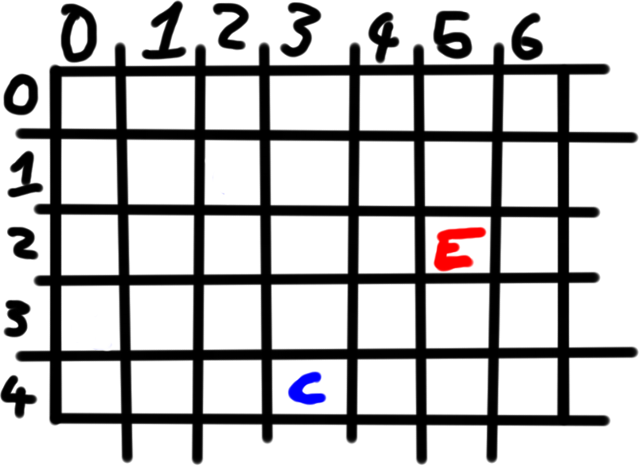

Stack Stack1;
Stack Stack2;

While(Ecol != xC && Erow != yC){
if (yC < Erow){
Erow--;
if (tile[Ecol][Erow] is a lake){
random(2);
if (random == 0){
Ecol--;
}else{
Ecol++;
}
}
Stack1.push(Ecol);
Stack2.push(Erow);
}
else if (yC < Erow){
Erow--;
if (tile[Ecol][Erow] is a lake){
random(2);
if (random == 0){
Ecol--;
}else{
Ecol++;
}
}
Stack1.push(Ecol);
Stack2.push(Erow);

}
else{
if (xC < Ecol){
Ecol--;
if (tile[Ecol][Erow] is a lake){
random(2);
if (random == 0){
Erow--;
}else{
Erow++;
}
}
Stack1.push(Ecol);
Stack2.push(Erow);
}
else if (xC < Ecol){
Ecol--;
if (tile[Ecol][Erow] is a lake){
random(2);
if (random == 0){
Erow--;
}else{
Erow++;
}
}
Stack1.push(Ecol);
Stack2.push(Erow);
}
}
}

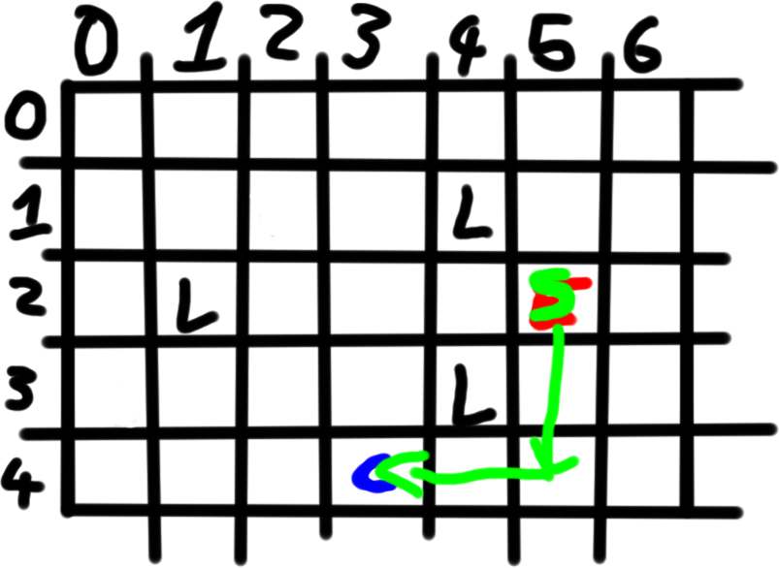

found a path

while(Stack1 is not Empty){
String temp1 = Stack1.pop();
String temp2 = Stack2.pop();
int col = parseInt(temp1) ;
int row = parseint(temp2);
EArmy.moveto(col, row);
turn++;
}

Got there

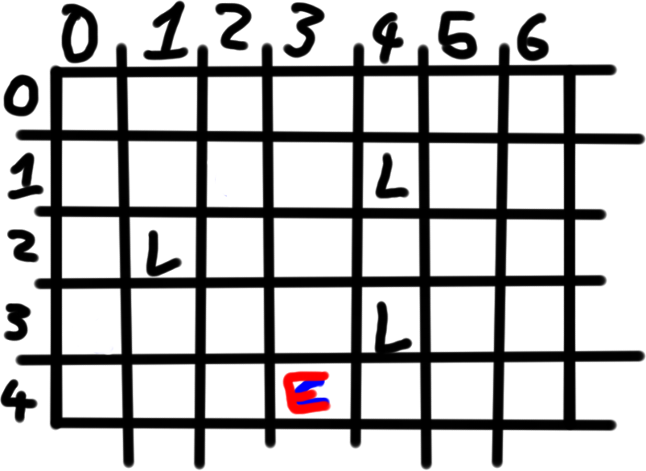

Do that whole thing about 2 more times (can be randomized)
Now do the same thing except find the player’s fortress

while (col <= 6 the last column){
while (row <= 4 bottom row){
if (Tile[col][row] is player fortress(base))
xList.add(col);
yList.add(row);
row++;
}
row = 0;
col++;
}

… the rest of the code.

